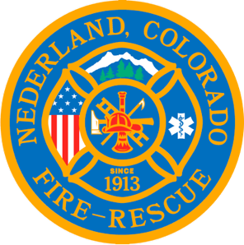

Nederland Fire Protection District Board of Directors Regular Meeting Agenda
May 15, 2024

** This meeting is being recorded **

Roll Call
Guy Falsetti -
Todd Wieseler –
Russ Panneton -
Bob Sheehan
Ryan Keeler

Chief Schmidtmann -

Announce Quorum & Call Meeting to Order @

Public Statements, Comments or Questions
(Please state name and if in district or out of district for the record)
Name District

Approve the meeting agenda.

Acceptance of previous meeting minutes

Treasurer’s Report

Chief’s Report

Old Business
- Pension board Update

New Business
- Keeping Citywide as a bank - Sherry

Special Executive Session

Special Meeting Conclusions

Public Statements, Comments or Questions
(Please state name and if in district or out of district for the record)

Any other business

Next Regular Board Meeting June 19, 2024 @ 7pm

Adjourn the meeting @

