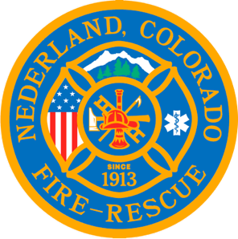

Nederland Fire Protection District Board of Directors Special Budget Meeting Agenda
January 8, 2024

** This meeting is being recorded **

Roll Call
Guy Falsetti – Present
Todd Wiesler – Present
Russ Panneton – Present (remotely)
Bob Sheehan – Present
Ryan Keeler – Present
Chief Schmidtmann – Present

Announce Quorum & Call Meeting to Order @ 19:17

Public Statements, Comments or Questions
None.

Approve the meeting agenda

Acceptance of previous meeting minutes
- 5-0-0

Old Business
- Budget for 2024

New Business

Senate Bill 23B and its anticipated effect on the 2024 budget
- Depending on the amount the state of Colorado reimburses the department, Chief Schmidtmann presented several possible distributions of expenses for 2024.
- The final amount of backfill will be known in April, at which time, the budget may be amended.
- Motion to approve 2024-02 tentative 2024 Budget with no backfill: 5-0-0

Resolution 2024-001 Reinstate Volunteer Pension Fund
- Chief Schmidtmann presented a spreadsheet with the maximum possible department pension contributions that would be required to bring all current members up to date for participation in The Volunteer Firefighter Pension Fund through FPPA (Fire and Police Pension Association).
- Without a thorough examination of firefighter participation in calls and training, the worst case would be $64,890 to bring all volunteers up to date.
- Motion to table Resolution 2024-001 until the next Board meeting to reinstate the pensions: 5-0-0

Transparency Notice
- Motion to approve Transparency Notice: 5-0-0

2024 Budget Cover Sheet
- Motion to approve Budget Cover Sheet: 5-0-0

Certification of Tax Levies
- Motion to approve Certification of Tax Levies: 5-0-0

Resolution to Set District Mill Levies
- Motion to approve Resolution to Set District Mill Levies: 5-0-0

Any other business
None.

Next Regular Board Meeting January 17, 2024 @ 19:00

Adjourn the meeting @ 22:01

