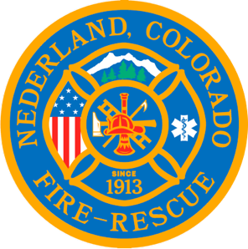

Nederland Fire Protection District Board of Directors Regular Meeting Agenda
June 19, 2024

** This meeting is being recorded **

Roll Call
Guy Falsetti -
Todd Wieseler –
Russ Panneton -
Bob Sheehan
Ryan Keeler

Chief Schmidtmann -

Announce Quorum & Call Meeting to Order @

Public Statements, Comments or Questions
(Please state name and if in district or out of district for the record)
Name District

Approve the meeting agenda.

Acceptance of previous meeting minutes

Treasurer’s Report

Chief’s Report

Old Business
- Pension Board Bylaws Review

New Business

Special Executive Session

Special Meeting Conclusions

Public Statements, Comments or Questions
(Please state name and if in district or out of district for the record)

Any other business
- Fourth of July Events

Next Regular Board Meeting July 17, 2024 @ 7pm

Adjourn the meeting @

