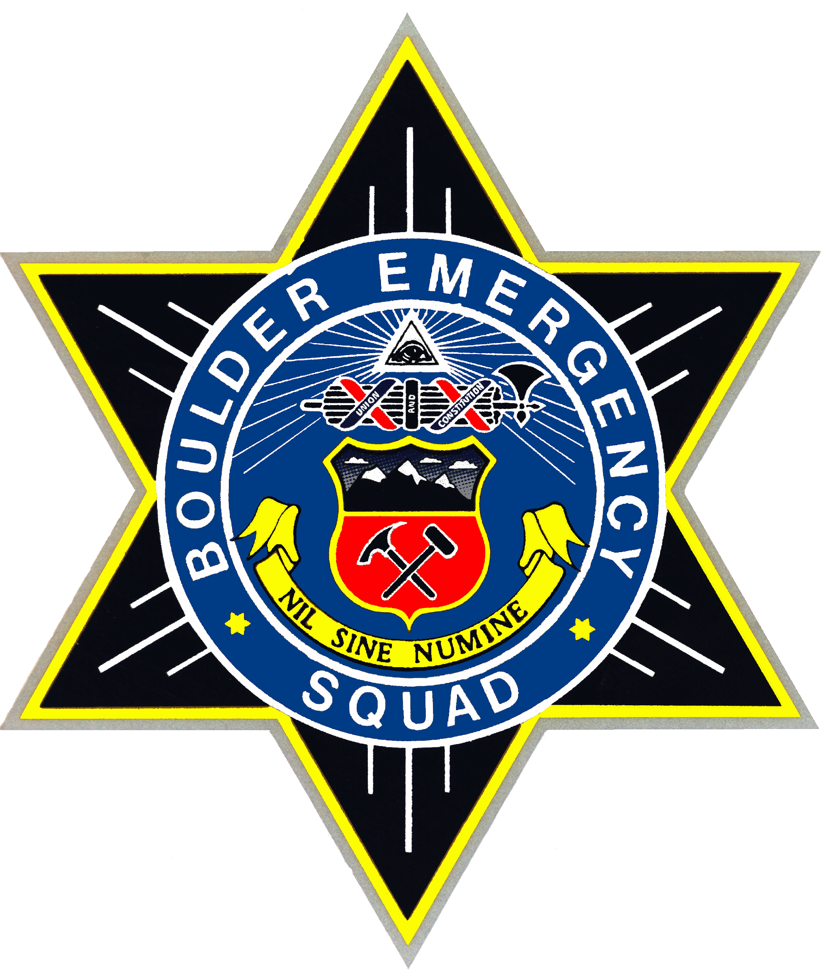

**Boulder Emergency Squad Nederland Fire Protection District**

P.O. Box 18887, Boulder, CO 80308 650 W 4th Street

3532 Diagonal Highway, Boulder, CO 80302 Nederland, CO 80403

**AUTOMATIC AID AGREEMENT**

This Agreement (“**Agreement**”) is made and entered into this 1st day of February 2025, by and between the Nederland Fire Protection District (“**NFPD”**) and the Boulder Emergency Squad Inc. (“**BES”**), collectively (the “**Agencies**”).

WHEREAS NFPD is responsible for fire, EMS, and rescue response within their district in Boulder County; and,

WHEREAS BES, an independent 501c.3 Colorado non-profit corporation, has the capability and resources to provide Rescue and Emergency Services (“**SERVICES**”) to the best of their ability as a volunteer response organization; and,

WHEREAS to improve, enhance, and supplement fire-rescue response and services within the NFPD district, the Agencies have agreed to Automatic Aid Response (“**AUTO AID**”) and Mutual Aid Response (“**MUTUAL AID**”); and,

NOW, THEREFORE, the Agencies agree as follows:

**1. SERVICES AND RESPONSE TO BE PROVIDED**.

BES agrees to provide the following services as a volunteer agency to the best of its ability:

1.1. BES shall provide an Auto Aid Response (“**AUTO AID**”) to all Major accidents call types [MAACCR] , including pinned injury, ejections, bus, train accidents, multi vehicle accidents and multi-casualty incidents.

1.2. BES shall provide emergency Auto Aid to all *confirmed* wildland fires in the NFPD district and provide a hand crew and Unmanned Aerial Systems (“**UAS**”), and if requested, the use of SARCOM 3155 as a mobile command and communications center for immediate deployment for up to one operational period.

1.3. BES shall provide emergency Auto Aid to all water-rescue incidents in the NFPD district. Per the Sheriff’s Office SAR Annex, BES *will* assume the role of Operations and/or Water Group Supervisor and work and operate within and at the direction of the established Incident Command (“**IC**”) structure.

1.4. BES shall provide a non-emergency (“**ROUTINE**”) Auto Aid response (unless otherwise requested) to all confirmed structure fires in the NFPD district and when requested by NFPD a Routine Mutual Aid (“**MUTUAL AID**”) response to other fire-related incidents to provide air cascade, UAS aerial recon, firefighter rehabilitation, and lighting.

1.5. BES, if the first arriving emergency services unit within the NFPD district, and if IC has not already been established, will establish IC for the incident and relinquish to the appropriate NFPD unit upon direction of NFPD officer.

1.6. When not auto-toned, BES may provide a Mutual Aid response at the request of NFPD to deliver other Services such as low angle rescue resources, scree evacuation, search and rescue requiring UAS, and other fire support Services.

1.7. BES and NFPD will mutually provide training for the Agencies as follows:

1.7.1. BES will invite and provide for a specific number of NFPD first responders (to be determined based on seat availability) to a BES sponsored and instructed swiftwater rescue training for shore support and in-water rescue technicians, and other training on an as needed basis that may include traffic management, ropes and rigging, and or extrication; and

1.7.2. NFPD will provide training, coaching and assistance by their senior fire rescue leaders to BES for officer development, quick response vehicle and other development programs as may be need from time to time, and

1.7.3. the Agencies may provide to one another additional fire-rescue related skills as mutually agreed.

**2. TERM OF AGREEMENT**.

The term of this Agreement shall be from February 1, 2025 through December 31, 2025 and will remain in force and automatically renew with its full terms and conditions until such time as one or both of the Agencies provide in writing a 30 day notice to terminate the Agreement by an official representative of either Agency to the Chief of the other Agency with a copy sent to the Boulder Sheriff Communications Center Director (“**BCC**”) indicating a change in the agreement.

In the event of a termination of this Agreement, as specified in this Section 2, the NFPD will pay the Contractor a prorated amount sufficient to cover any unpaid services already provided by Contractor and the Contractor will reimburse to the NFPD any funds it was paid, but for which it will not be providing services as a result of the termination.

**3. COMPENSATION FOR SERVICES**.

The AFPD, as compensation for the services purchased by this Agreement, agrees to pay the BES TWO THOUSAND DOLLARS ($2,000) for 2025 and ($3,000) annually thereafter until the Agreement is terminated per paragraph 2. of this Agreement, which sum shall be payable to the Contractor in one payment no later than March 1, 2025, and prior to January 31st of each year thereafter.

**4. LIMITATIONS OF BES RESPONSES**.

This agreement will not be interpreted in such a way as to:

1. Limit BES’s operations when requested by Boulder County Colorado, the Boulder County Sheriff Office, or agencies other than the NFPD for areas outside of the NFPD. The NFPD recognize that BES also assists other agencies with requests for the services described in this Agreement. If BES is participating in other resources when it receives a request for assistance from the NFPD then BES has the authority to determine what resources, it has available to respond to the request by the NFPD.
2. Require BES to assign or lend its corporate-owned equipment to other Persons or agencies.

[*SIGNATURE PAGE*]

This signed Agreement shall be submitted to the BCC for use in dispatching the Agencies.

**Nederland Fire Protection District**: **Boulder Emergency Squad**:

NFPD Chief/Representative: Andrew M. Amalfitano

________________________________ ________________________________ President & Chief

Date: ________________ Date: ______________

[*SIGNATURE PAGE*]

____________________________________________________________________________________