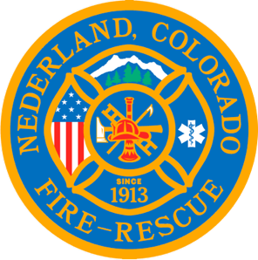

Nederland Fire Protection District Board of Directors Regular Meeting Agenda
May 2, 2024

** This meeting is being recorded **

Roll Call
Guy Falsetti -
Todd Wieseler –
Russ Panneton -
Bob Sheehan
Ryan Keeler

Chief Schmidtmann –

Pension Board
Amanda Papich
Larissa Briscombe

Announce Quorum & Call Meeting to Order @

Public Statements, Comments or Questions
(Please state name and if in district or out of district for the record)
Name District

Approve the meeting agenda.

Acceptance of previous meeting minutes

Old Business

New Business
- Review of Pension Bylaws

Special Executive Session

Special Meeting Conclusions

Public Statements, Comments or Questions
(Please state name and if in district or out of district for the record)

Any other business

Next Regular Board Meeting May 15, 2024 @ 7pm

Adjourn the meeting @

