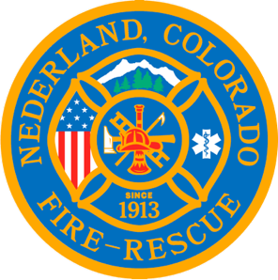

Nederland Fire Protection District Board of Directors Regular Meeting Agenda
July 19th 2023

** This meeting is being recorded **

Roll Call
Todd Wieseler - Y
Guy Falsetti – Y
Russ Panneton – Y

Interim Chief Schmidtmann -Y

Announce Quorum & Call Meeting to Order @

Approve the meeting agenda
5-0-0

Acceptance of previous meeting minutes

Oaths of Office
Bob Sheehan
Ryan Keeler

(Optional) Recess Public Meeting for Filing of Oaths @

Resume Public Meeting @

Roll Call
Guy Falsetti -
Todd Wiesler –
Russ Panneton -
Bob Sheehan
Ryan Keeler

Announce Quorum & Call Meeting to Order @

Motions to Select Members to Board Positions
Open Secretary position
Do we what to roles

Public Statements, Comments or Questions
(Please state name and if in district or out of district for the record)
Name District

Treasurer’s Report

Chief’s Report

New Business

Old Business
Report from search team on Hiring Process

Special Executive Session

Special Meeting Conclusions

Public Statements, Comments or Questions
(Please state name and if in district or out of district for the record)

Any other business

Next Meeting August 16th @ 7pm

Adjourn the meeting @

